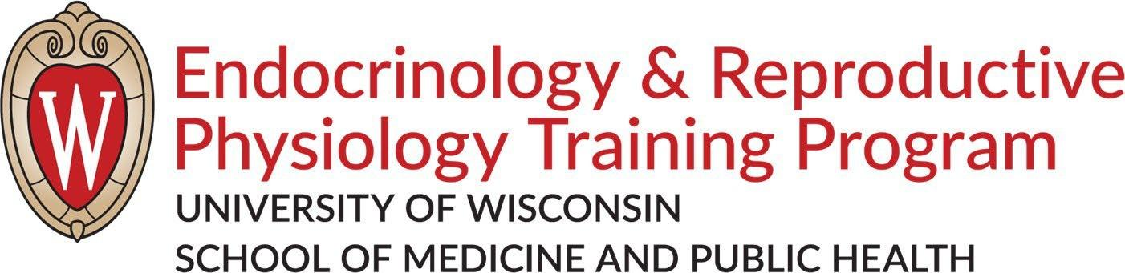
Fall 2026 INCOMING STUDENT CHECKLIST & LAB ROTATION INFO
Welcome to the Endocrinology and Reproductive Physiology Program!

Before Arrival in Madison
- Activate your NetID through the My UW-Madison portal at my.wisc.edu
- Enroll in classes
- Work with ERP Office to establish lab rotation schedule

Upon Arrival in Madison
- Check in with International Student Services (ISS) (international students only)
- Provide I-9 information to verify payroll to HR Team Member (refer to your appointment letter)
- New Student Welcome Week Events (additional optional events described in Canvas course below)

Monday, August 24th ERP & Interdisciplinary Biological & Health Sciences Consortium Welcome Events (Health Sciences Learning Center building, 750 Highland Ave.)

HSLC Room 3330 (2nd level of Ebling Library)
8:30am: Bagels, Fruit & Coffee Welcome with ERP Director, Laura Hernandez & MET Director, Sathish Kumar
8:45-9:05: Office of Student Assistance & Support (Elaine Goetz, Graduate & Professional Student Assistance Specialist)
9:10-9:30: Ebling Library Resources, including Mini-tour (Paije Wilson, Health Sciences Librarian)
9:35-9:45: Break
9:45-10:15 ERP Program Overview with ERP Director
10:15-10:45: Q&A with Current ERP Students (Wenyan Bai, 3rd year & McKenna Crossen, 2026 alum)
10:45-11:00: Break & transition to IBHSC Lunch HSLC Rooms 1220-1222

11:00am-1:30pm: Interdisciplinary Biological and Health Sciences Consortium Welcome Lunch
1:45-3:00 [Optional] walking tour with current students, Jojo Maier, Ben , (visit classrooms in HSLC, SMI, MSABD plus ERP office in Hanson and Union South)
4:30pm [Optional] Bioscience Student Welcome Social in the Microcosm Cafe (Microbial Sciences Building, 1550 Linden Dr). Refreshments and appetizers will be served.

- Complete Canvas Course for New IBHSC Students
General and ERP Modules (disregard program info from other programs)
    - Required Sexual Violence Prevention Training
    - Required Online Lab Safety Trainings
      - Chemical Safety Training: The OSHA Lab Standard
      - Biosafety Required Training (Biosafety 101, 104, 201)
▪ Required SMPH Trainings within 1st week
      - Review Acceptable Use of Information Technology Resources Policy
      - HIPAA Training
▪ Required SMPH Trainings within 1st two weeks
      - Mandated Reported Training
      - Creating a Respectful and Welcoming Learning Environment Training
▪ Required SMPH Trainings within 1st month
      - Cybersecurity Awareness Training
      - Review SMPH Shared Guidelines for Professional Conduct
- Ask faculty you’ll rotate with about other required trainings.

- Benefits
  - Attend a Payroll & Benefits Drop-in session
  - Complete Benefits paperwork and turn in to Payroll & Benefits Services by deadline.
  - BE AWARE: You’ll need to repeat this process during Open Enrollment in October
- Other Resources
  - Wiscard = Official UW Photo ID
Pick up on first floor of Union South (included on Tuesday’s optional walking tour)
https://wiscard.wisc.edu/id-card/how-to-get-your-wiscard
  - FREE Madison Metro Bus Pass for Students
https://transportation.wisc.edu/commuter-solutions/bus/student-bus-pass-program/#fall-2025-pickup
- ERP Program Office:
Room 205, Hanson Biomedical Sciences, 1656 Linden Drive, Madison, WI 53706
Building doors are locked; call landline 608-265-5838 office & Bootsy will let you in

Fall 2026 LAB ROTATION INFO
see also ERP Student Handbook Rotations section

What To Expect

Rotations are the time spent in different labs of your choice (usually 3) during the first semester on campus. You will spend 1 month per lab to help you decide which lab you want to be part of.
The expectations of each professor will vary. Talk to the professors directly to see what they expect from students. Likely, it will be that you will spend a few hours a day in lab observing and doing a few experiments over the month you are there. During this time you have a lot of observing to do in order to help you make your final lab decision.

Matching With a Lab/Advisor
Professors and students cannot make formal agreements until all rotations are done.

In late November, you will be matched with an advisor based on mutual interests of you (rank order of faculty with whom you rotated) and the faculty member (rank order of students who rotated with the faculty member).
- Rotation matches are finalized through the program office with consultation between the student and the faculty member.
- Faculty members are not obligated to accept your request that they serve as your primary advisor.
- If no suitable match is found, you may be eligible for one or more additional rotations, based on your academic progress and availability of funding.

Considerations While Rotating

- How much guidance does the professor offer?
  - Some students have had their dissertation topic mapped out for them.
  - Some students have developed their thesis ideas on their own

  - MORE IMPORTANTLY –
o How much guidance do you need?
o Is this lab going to give you the help and structure you need?
o Is this lab going to give you the freedom you are looking for?
- How much is the professor around?
  - Do they travel a lot?
  - Do they have specific hours they are in their office?
  - How available are they

- What is the model system of the lab?
  - If you are allergic to animal dander or uncomfortable with euthanizing animals, consider avoiding labs that use these models

- Lab environment/atmosphere
  - Some labs have music on
  - Some labs have a lot of talking and interaction
  - Some labs are quiet
  - Some labs are competitive
o What are the people like in the lab you’d like to be in?
o Can you work in the atmosphere you observed during rotation?
o Can you get along with the other students in the lab?
o Can you get along with the lab technicians?
- What about the professor?
  - Do you like the professor?
  - Does the professor have a personality that you can work with and learn from?
  - Do you feel the professor has reasonable expectations of students?
  - Do you feel the professor will be a good mentor for you?

- Talk with the students!
  - What do they like and/or dislike about the lab?
  - Is there competition for equipment?
  - What happens when a student messes up an experiment?
  - What are lab meetings like?

- Are you interested in the research project?
  - Does it sound good on paper, but once you get there are you thinking it is not so great after all?
  - NEVER be intimidated by a lab because you don’t really understand what they are working on. You might just find a new area of interest you never thought of!

